**ADMINISTRATION/MIS**

**SYSTEM USERS-Completed**

Administrator

Vice Chancellor

Registrar

Bursar

Librarian

Director Academic Planning

Admission Officer

Dean

HOD

HRM Staff

Lecturers

Admin Staff

Accommodation Officer

Students

Parents

**FRONT OFFICCE-Completed**

General Enquiry

Visitor Logs

Phone Call Logs

Postal Dispatch

Postal Receive

Complaint

**HUMAN RESOURCES-Pending**

Staff

Attendance

Payroll

Staff leave

Faculty

Department

Designation

Staff ID Cards

Student ID Cards

**HOSTEL-Completed**

Hostel

Room Type

Rooms

Beds

**INVENTORY-Completed**

Item Category

Add Item

Issue Item

Item Supplier

Store

**ADMISSION MANAGEMENT**

**ADMISSIONS**

Admission Enquiry-Website table to be created

Application

Screening

Registration

Faculty and Department Transfer

Sessions

**STUDENTS-Completed**

Student Details

Student Categories

Disable Students

Delete Student

**FACULTY MANAGEMENT**

**STRUCTURE**

Faculty

Department

Sessions

Levels

Semesters

Classrooms

**ACCADEMICS-Completed**

Course and credit unit. Registration

Exams

Marks

Discussion Forum

Attendance

Study Materials

Assignments

Online Classes-To be complete

Timetable

Online Exams

Result

**FEES MANAGEMENT-Completed**

Fee type

Fee group

Income

Expenses

Discounts

**MESSAGING MODULE-Complete**

Notice Board

Online Meetings

Emails

SMS

Chat

File Sharing

Calendar

Tasks

Polls

**LIBRARY MODULE AND CONSULTANCY-Complete**

Books (physical and eBooks)

Issue/Return Books

**RESULT COMPUTATION**

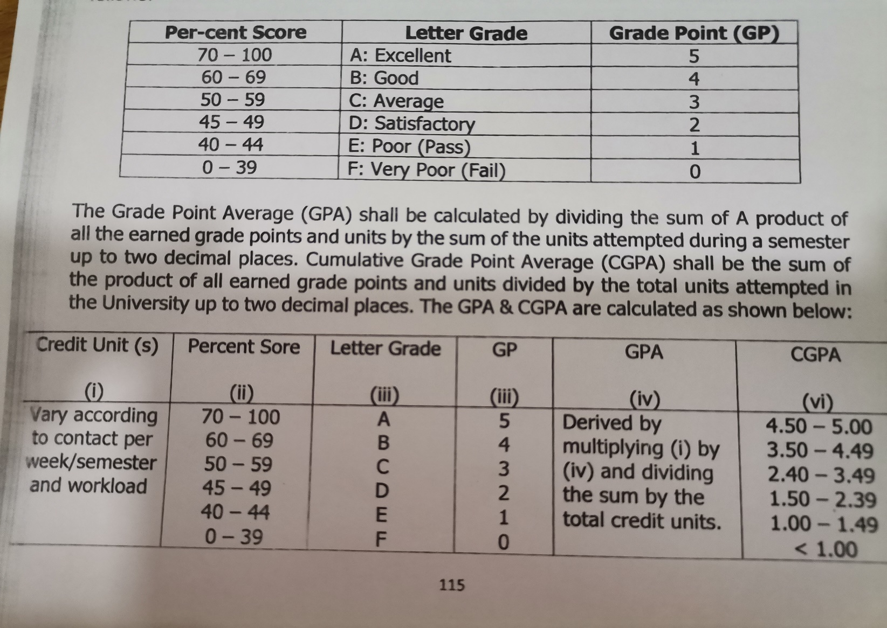**Based on a semester, credit unit and CGPA system**

**SAMPLE STUDENT RESULT TEMPLATE.**

|  |  |  |  |
| --- | --- | --- | --- |
| **S/N** | **COURSE** | **TOTAL SCORE** | **GRADE** |
| 1 | PSY 101 | 92 | A |
| 2 | ECO 203 | 51 | C |
| 3 | GOV 123 | 34 | F |
| 4 | ENT 211 | 64 | B |
| 5 | SOC 111 | 42 | E |
| 6 | PSY 104 | 88 | A |
| 7 | PSY 321 | 70 | A |
| 8 | GST 121 | 49 | D |

**GPA**: 2.31 **CGPA**: 3.65